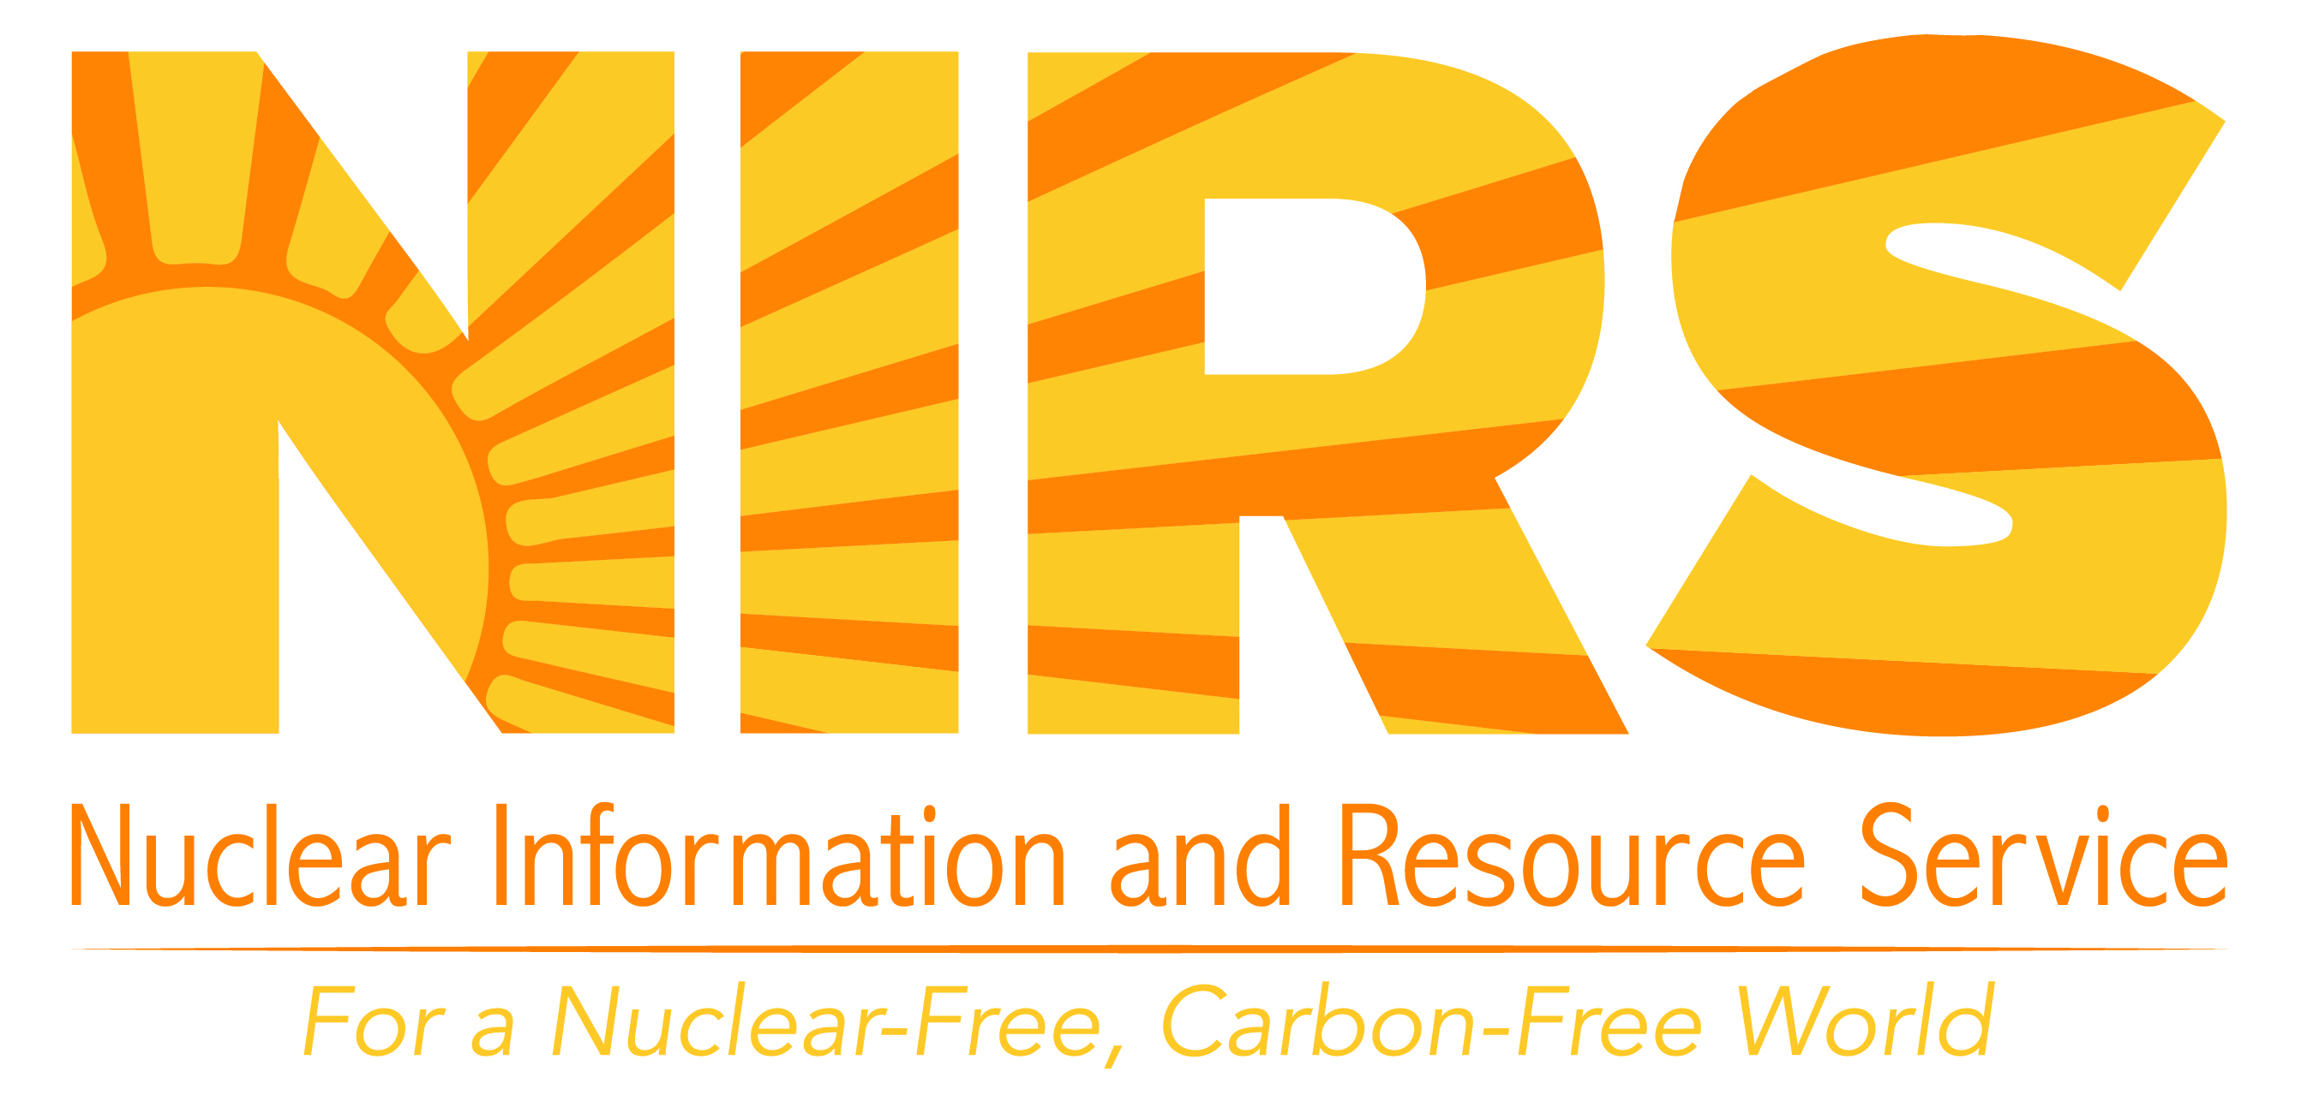

**WWW.NIRS.ORG**

6930 Carroll Avenue, Suite 340

Takoma Park, MD 20912

(301) 270- NIRS (6477)

**Consolidated “Interim” Storage**



**Consolidated/Centralized “Interim” Storage** (CIS) **Nuclear Waste Dumps** would be sites to which high level nuclear power waste (in the form of irradiated nuclear fuel) would be moved before being shipped to a currently non-existent permanent repository.

Such facilities would allow the storage of commercial irradiated fuel (sometimes called “spent” or “used” fuel) from all the US nuclear power reactors across the country to an additional nuclear sacrifice area. As of 2018, there are two proposed Consolidated “Interim” Storage Dumps—one in Texas and one in New Mexico. There have been suggestions for locations in other states and one site was licensed in Utah but never operated.

**Why are supposedly “Interim” Dumps a BAD IDEA?** They are dangerous for several reasons:

* Unnecessary transport of deadly waste spreading and multiplying risks and hazards
* Failure to improve existing vulnerability of nuclear waste storage technology
* Increases the number of radioactive sites
* Supposedly “interim” sites could become permanent by default
* Consolidating waste in one place can lead to Reprocessing
* Reprocessing makes worse waste, spreads contamination and leads to proliferation of nuclear weapons.

If consolidated sites are opened, the irradiated fuel would move multiple times through our communities–from the reactors that made it to the supposedly temporary site and again to a permanent repository. The transport of irradiated nuclear fuel is extremely risky. (See NIRS **Hot Cargos** factsheet.)

An accident or attack on a high-level waste shipment could permanently contaminate a huge area and spread radioactivity very far. Land, water and air within 50 miles or more of the accident site could be contaminated with uninhabitable radiation levels. Even with no incident, routine shipments legally emit radiation.

It is likely that an “interim” site could become a de-facto permanent storage site if a morally and scientifically sound permanent system to isolate the waste is not developed.

Consolidated waste sites are not designed to store irradiated nuclear fuel for the millions of years it remains radioactively dangerous.

Consolidating irradiated nuclear fuel could lead to **reprocessing** which makes the nuclear waste problems much worse and leads to increased nuclear weapons proliferation dangers. No reprocessing sites have ever been cleaned up…they are costing billions to prevent from getting worse.

[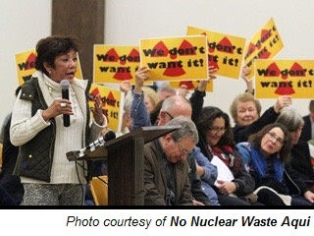](http://nonuclearwasteaqui.org/2017/02/we-do-not-consent/)

**Consolidated “Interim” Storage is ILLEGAL**

The current federal law, 1982 Nuclear Waste Policy Act and 1987 Amendments, states that consolidated “interim” storage is allowed ***only*** ***if*** a permanent repository is operating. Moreover, the provision of the law allowed a “temporary” site ***expired***, making any such facility ***illegal***.

Despite the illegality, two private corporations applied to open such sites and the NRC is proceeding with their applications.

Application 1: [**Waste Control Specialists**](https://www.nrc.gov/waste/spent-fuel-storage/cis/wcs/wcs-app-docs.html) **(WCS) Orano USA and NAC International** seek to store **40,000** metric tons on their TX site bordering NM. The Nuclear Regulatory Commission (NRC) determined the WCS original high level waste application ready for legal review in January 2017, but later suspended the process. WCS was sold to J.F. Lehman in 2018 and announced they will resume the application. WCS operates a “low-level” radioactive waste and hazardous treatment and disposal site for nuclear power and weapons waste in Andrews County, Texas.

Application 2: The **Eddy Lea Energy Alliance** in conjunction with **Holtec International** is applying for a license to “temporarily” store **100,000 metric tons** (with **potential for 120,000**) of irradiated nuclear fuel in holes in the ground in SE New Mexico, east of Carlsbad. The application is expected to be declared complete in May 2018, opening it to public comments and intervention. ***Comments on the Environmental Impact Statement scope are due 29 May 2018.***

There are legal opportunities to comment and intervene in both licensing proceedings.

**These corporations want to change the law to allow them to make money while all liability is borne by the public.** They want:

* Legalizing consolidated “interim” storage before there is a permanent repository.
* Shift of liability for and ownership of the high-level waste from nuclear power companies that generated and own it to the US Department of Energy aka US taxpayers.
* Use of Nuclear Waste Fund money collected for permanent isolation to be redirected to them for so called “interim” storage.

New Mexicans and Texanswith local, regional and national allies are working to prevent the proposed parking lot dumps. Such dumps and the 40 years and thousands of shipments to them not only threaten safety, security and economics; they violate the principles of environmental justice. People of color would be affected disproportionately if nuclear waste were brought to the Eddy Lee/Holtec or the WCS sites.

New Mexicans and Texans do not consent to either of the proposed parking lot dumps and are fighting to avoid the environmental injustice and the unnecessary shipment of irradiated high level nuclear waste through and to their communities.

**What Should Be Done?** The amount of waste should be limited and efforts focused on isolating that which has been generated. As of 2018 there are ~ 80,000 metric tonnes of commercial irradiated fuel in the US with ~2,000 more generated every year. Rather than move waste thousands of miles back and forth across the country, it should be stored more securely in Hardened On-Site Storage, HOSS, in containers that can be monitored, a concept supported by organizations in every state. Better storage containers and systems are needed no matter where the waste is located, since it must be isolated for literally millions of years.

Don’t *Nuclear* Waste America

[www.nirs.org](http://www.nirs.org); <https://www.nirs.org/campaigns/dont-waste-america/>

APRIL 2018

