PEOPLE’S CLIMATE MARCH.
NEW YORK CITY.
SEPTEMBER 21.
NUCLEAR-FREE, CARBON-FREE CONTINGENT.
JOIN US!
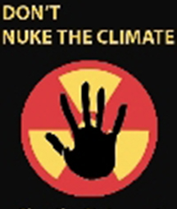

REASON #2: NUCLEAR POWER COSTS TOO MUCH
Construction of the 1,500 new reactors (200-300 in U.S. alone) needed for nuclear power to have a significant impact on carbon reductions would cost trillions of dollars. New reactors cost some $7 billion to $15 billion each. Use of resources of this magnitude would make it impossible to also implement more effective means of addressing global warming. Energy efficiency improvements, for example, are some seven times more effective at reducing greenhouse gases, per dollar spent, than nuclear power.

nirsnet@nirs.org
http://www.nirs.org
http://peoplesclimate.org/nonuclearpower/

