PEOPLE’S CLIMATE MARCH.
NEW YORK CITY.
SEPTEMBER 21.
NUCLEAR-FREE, CARBON-FREE CONTINGENT.
JOIN US!
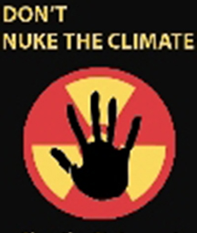

REASON #3: NUCLEAR POWER WOULD TAKE TOO MUCH TIME
Construction of the 1,500 new reactors needed to make a meaningful dent in carbon emissions would mean opening a new reactor about once every two weeks, beginning today, for the next 60 years—an impossible schedule and much too late to achieve necessary carbon reductions. The world’s nuclear reactor manufacturers currently are capable of building less than half that amount. Addressing the climate crisis cannot wait for nuclear power.

nirsnet@nirs.org
http://www.nirs.org
http://peoplesclimate.org/nonuclearpower/

