PEOPLE’S CLIMATE MARCH.
NEW YORK CITY.
SEPTEMBER 21.
NUCLEAR-FREE, CARBON-FREE CONTINGENT.
JOIN US!
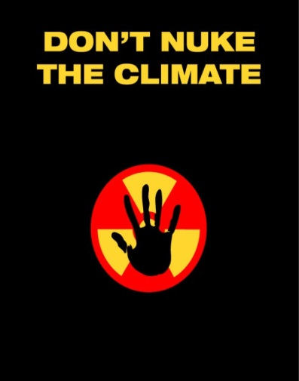

REASON # 10: A NUCLEAR-FREE, CARBON-FREE ENERGY SYSTEM IS SAFER, CLEANER, CHEAPER AND FASTER AT REDUCING CARBON EMISSIONS
If we could meet our electricity needs without radioactive waste, nuclear meltdowns, releases of carbon and methane and all the other environmental destruction associated with extraction of nuclear and fossil fuels from the Earth, why wouldn’t we? Just a few years ago, solar and wind power weren’t competitive with nuclear power or fossil fuels. Now, both are usually cheaper than the polluting power choices. It is increasingly affordable for homeowners to install solar power plants on their rooftops—a new solar rooftop system is installed in the U.S. every 4 minutes, a number that will drop to every 90 seconds by 2016.
Smart grids, distributed generation and other 21st century technologies enable the large-scale use of renewables despite their variable nature. And advances in battery and other storage technologies mean that both rooftop solar and larger-scale renewable power plants can provide power 24/7—just like the behemoth nuclear and coal “baseload” power plants of the 20th century.
Numerous studies show conclusively that a nuclear-free, carbon-free energy system is attainable before mid-century. The technology is not the issue; only political will now stands in the way. Our choice is stark: we can choose nuclear power, or we can address global warming. We can’t do both. Fortunately, the choice is an easy one.

nirsnet@nirs.org
http://www.nirs.org
http://www.nirs.org/climatemarch/climatemarchhome.htm

