PEOPLE’S CLIMATE MARCH.
NEW YORK CITY.
SEPTEMBER 21.
NUCLEAR-FREE, CARBON-FREE CONTINGENT.
JOIN US!
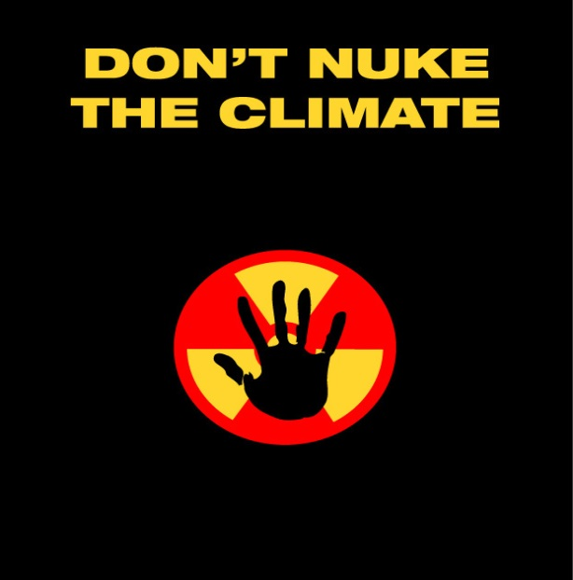

REASON # 6: TOO LITTLE SAFETY
Odds of a major nuclear disaster are said to be on the order of 1 in 10,000 reactor-years, but experience shows accidents occur even more frequently. Operation of some 1,500 reactors needed for nuclear power to play a meaningful role in reducing carbon emissions could result in a Fukushima-scale nuclear accident every five years—a price the world is not likely to be willing to pay. And more reactors means more potential terrorist targets.

nirsnet@nirs.org
http://www.nirs.org
http://peoplesclimate.org/nonuclearpower/

