PEOPLE’S CLIMATE MARCH.
NEW YORK CITY.
SEPTEMBER 21.
NUCLEAR-FREE, CARBON-FREE CONTINGENT.
JOIN US!
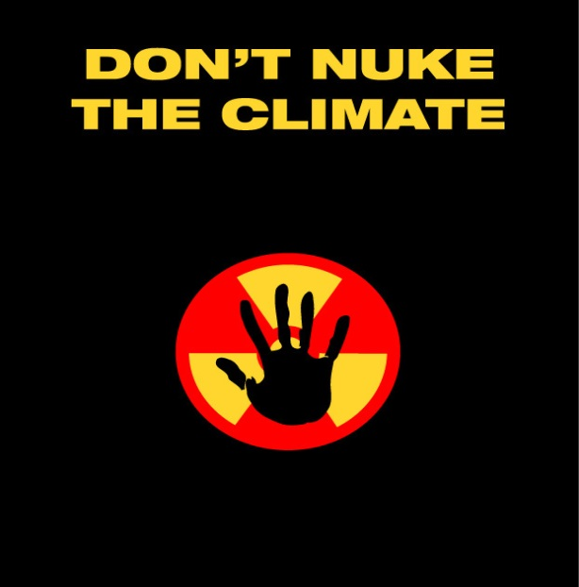

REASON # 7: TOO MANY NUCLEAR WEAPONS
Operation of the 1,500 or more new reactors necessary for nuclear power to play a meaningful role in reducing carbon emissions would require a dozen or more new uranium enrichment plants, and would result in the production of thousands of tons of plutonium (each reactor produces about 500 pounds of plutonium per year), posing untenable nuclear proliferation threats.

nirsnet@nirs.org
http://www.nirs.org
http://peoplesclimate.org/nonuclearpower/

