PEOPLE’S CLIMATE MARCH.
NEW YORK CITY.
SEPTEMBER 21.
NUCLEAR-FREE, CARBON-FREE CONTINGENT.
JOIN US!
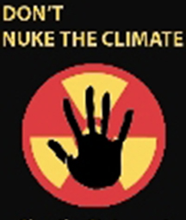

REASON #1: TOO MANY REACTORS, NOT ENOUGH CARBON REDUCTIONS
Major studies (from MIT, Commission on Energy Policy, and International Atomic Energy Agency, for example) agree that about 1,500-2,000 large new atomic reactors would have to be built worldwide for nuclear power to make any meaningful dent in greenhouse emissions (fewer than 400 reactors now operate globally). If all of these reactors were used to replace coal plants, carbon emissions would drop by only about 20% worldwide. If used as new capacity instead of sustainable technologies like wind power, solar power, energy efficiency, carbon emissions actually would increase.

nirsnet@nirs.org
http://www.nirs.org
http://peoplesclimate.org/nonuclearpower/

