PEOPLE’S CLIMATE MARCH.
NEW YORK CITY.
SEPTEMBER 21.
NUCLEAR-FREE, CARBON-FREE CONTINGENT.
JOIN US!
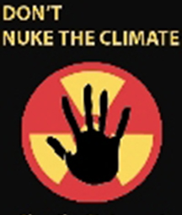

REASON # 5: TOO MUCH RADIOACTIVE WASTE
Operation of the 1,500+ new reactors needed for nuclear power to make a dent in carbon emissions would create the need for a new Yucca Mountain-sized radioactive waste dump every 3-4 years. Yucca Mt. was studied for 20 years before being dropped by President Obama as a nonviable waste solution. International efforts to site radioactive waste facilities are similarly behind schedule and face substantial public opposition. For this reason, the nuclear industry wants to reprocess nuclear fuel as a waste management tool—a dirty, dangerous and failed technology that increases nuclear proliferation risks.

nirsnet@nirs.org
http://www.nirs.org
http://peoplesclimate.org/nonuclearpower/

