PEOPLE’S CLIMATE MARCH.
NEW YORK CITY.
SEPTEMBER 21.
NUCLEAR-FREE, CARBON-FREE CONTINGENT.
JOIN US!
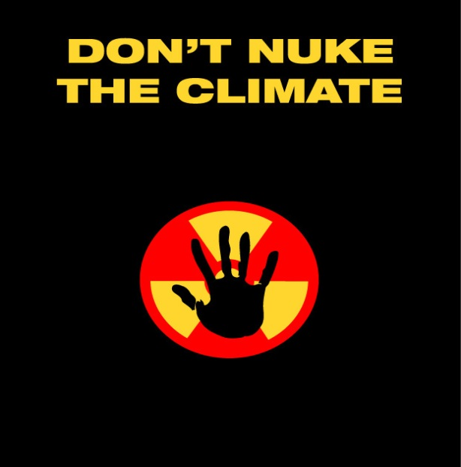

REASON # 8: NUKES ARE NOT CARBON-FREE
While nuclear reactors themselves are not major emitters of greenhouse gases, the nuclear fuel chain produces significant greenhouse emissions. This chain includes uranium mining, milling, processing, enrichment, fuel fabrication, and long-term radioactive waste storage. At each of these steps, construction and operation of nuclear facilities results in carbon emissions. Taken together, the fuel chain greenhouse emissions are more than double solar power emissions, which are declining as the industry becomes more efficient, and some six times higher than wind power—not to mention emissions-free energy efficiency technologies.

nirsnet@nirs.org
http://www.nirs.org
http://www.nirs.org/climatemarch/climatemarchhome.htm

