PEOPLE’S CLIMATE MARCH.
NEW YORK CITY.
SEPTEMBER 21.
NUCLEAR-FREE, CARBON-FREE CONTINGENT.
JOIN US!

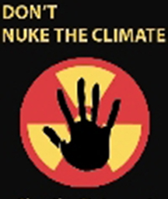

The climate crisis is the defining issue of our time. It poses an existential threat to life on Earth in a manner civilization never before has faced. Immediate action is necessary to slash climate-changing emissions in all sectors of society.

On September 21, 2014, the Nuclear-Free, Carbon-Free Contingent will join the historic People’s Climate March in New York City to demand immediate action from all of the governments of the world.

The solutions to the climate crisis are not difficult to identify. A nuclear-free, carbon-free energy system is a necessity. It is an energy system that relies not on antiquated energy models of the 20th century and their polluting nuclear power and fossil fuel technologies, but on the safe, clean, affordable and sustainable renewable energy, energy efficiency, and modern grid technologies of the 21st century.

All that is lacking is the political will to rapidly deploy these clean technologies. On September 21, we march to break the gridlock and demonstrate to the world that this will exists.

nirsnet@nirs.org
http://www.nirs.org
http://www.nirs.org/climatemarch/climatemarchhome.htm

